Tolkien Reading Day 2021: ‘Hope and Courage’ Resource Pack

This is the resource pack for teachers and librarians for the Tolkien Reading Day 2021. It includes a range of activities that can be used on the day itself or for a range of extra-curricular workshops around the day. There is no designated order to the resources, it is up to the organiser to plan their own event.
For the Reading Day, the Tolkien Society is teaming up with the Centre for Fantasy and Fantastic at the University of Glasgow and are using the hashtags #TolkienReadingDay and #TolkienReadingDay2021 which we encourage everyone taking part in the Reading Day to use. You can take part in this by sharing pictures of your event and the work produced on your institute’s website and social media pages. If you do, you must ensure you follow the privacy laws and regulations of your country (e.g. GDRP) and please do include the hashtag provided.
For the Reading Day we are sharing three extracts from Tolkien’s works for the Tolkien community to engage with. We are asking members to share their reflections on the extracts and to explain how these extracts or other moments in Tolkien’s works have inspired hope or courage in their lives. This could form a discussion but also a written task where your attendees write about moments of hope and courage in their own lives. The extracts from The Hobbit, The Lord of the Rings, and The Silmarillion can be found on the Tolkien Society website.
Age and ability: The activities have deliberately not been labelled with a specific year group as they could be adapted for any year. Challenge questions and activities have been provided in case you wanted to use them for more able or older students.
These resources have been loosely planned in order for you to differentiate and adapt them for your attendees. If you are unable to provide in-person events then you could still arrange virtual gatherings where attendees complete activities together.
If you are using this resource for your students then you could similarly ask students to complete the activities remotely and share their creations with you.

Sustainable Hobbit Holes
Resources: Print out enough copies of appendix A for your group.
Time: 15/20 minutes to plan. Presentation time dependable on group size.
Skills/Subjects: Critical thinking skills. Science, PSHE, Art.
Instructions
Here is a chance for your attendees to create their own Hobbit hole. They can work independently or in small groups (2-3). Hand out enough copies of appendix A and give them the following instructions: they must make the most sustainable Hobbit hole that they can; they are only allowed five items of vegetation and two animals. They can decorate the inside and hilltop with whatever they want.
You could make it competitive with prizes for the most sustainable!
Challenges
1) Discuss the following questions:
i) Why is sustainable living important?
ii) How can we embrace a more sustainable life-style?
iii) What can we learn from the ways that Hobbits live?

________________________________________________________________

Uruk-hai Bootcamp (Move it you slugs!)

Resources: You could use a range of objects (cones, chairs, poles etc.) If your attendees are at home then they could use objects around them such as pillows, toys, books etc.
Time: Dependable on group size and the length of the course.
Skills/Subjects: Hand-eye co-ordination, foot work, agility skills. Physical Education.
Instructions
Either you or your attendees can make this and it can be as simple or complex as you/they want with as many or as little obstacles as you/they have at your/their disposal. Simply create an obstacle/race course and then do it or get participants to race each other – offer prizes for the quickest Uruk.
Challenges
1) Time each attendee for their first lap and then challenge them to beat their time with a second lap.
2) Race two attendees at once.

Create your Own Character

Resources: Print out enough copies of appendix B for your group (double sided if doing the challenge).
Time: 10/15 minutes to create the character. Up to 30 minutes to write and edit the character description.
Skills/Subjects: Language and writing skills. English language and literature.
Instructions
Ask attendees to create their own character from one of the peoples of Middle-earth: Hobbit, Rohirrim, Gondorian, Orc, Goblin, Elf, Dwarf etc.
Challenges
1) Ensure you have printed off both sides of appendix B. Ask attendees to describe their character using imagery, similes, metaphors and other descriptive features. You may want to challenge them to describe their personality.
2) Have attendees share their characters and use it as a starting point for a discussion of character creation and narratology using these questions:
i) What makes a good narrative character? What are examples of good
characterisations in something you’ve read or watched recently?
ii) How does using characteristics from Middle-earth shape your characters? How
would they act in our world?
iii) What are the implications of building a character in a fantasy world versus a world
like ours?

________________________________________________________________

I Sit and Think

Resources: Print out enough copies of appendix C and provide enough lined paper for your group.
Time: 1 hour (20 minutes to plan, 40 minutes to write).
Skills/Subjects: Language and writing skills. English language and literature.
Instructions
To help with this task, you may want to ask your attendees to read the extracts on the Tolkien Society website before planning and writing. You could also show them a clip from a film adaption on a video streaming website.
Option A: Write a diary entry from the perspective of Bilbo Baggins after his encounter with Smaug. Focus on Bilbo’s thoughts and feelings before, during, and after meeting the dragon.
Option B: Write a diary entry from the perspective of Samwise Gamgee after his encounter with the spider, Shelob. Focus on Sam’s thoughts and feelings before, during, and after meeting and fighting the spider.
Option C: Write a diary entry from the perspective of Lúthien after her encounter with the Vala, Morgoth. Focus on Lúthien’s thoughts and feelings before, during, and after meeting the Vala.
Challenges
1) Encourage attendees to use the features of a diary entry (‘Dear diary…’, informal, personal language).
2) Encourage attendees to show the characters feelings and emotions, rather than tell.

________________________________________________________________

Words, Script, Action!
Resources: Provide enough lined paper for your group.
Time: 1-2 hours (30 minutes to plan, 30 minutes to 1.5 hours to write and rehearse).
Skills/Subjects: Scriptwriting, oral and physical communication, construction skills. English language and literature, drama and performance.
Instructions
Based on the extracts from Tolkien’s texts (found on the Tolkien Society website), ask attendees to write a short script that brings the scene to life. They should ideally act it out themselves and can be challenged to think about lighting, props, and sound effects.
Alternatively, they could bring to life another moment from Tolkien’s works that links to hope and courage. Due to copyright, do not allow them to film and share this.
Challenges
1) Attendees can be challenged to think about the importance of lighting, props, and sound effects when dramatizing a scene.
2) Questions for discussion:
i) How does the text change when reading versus acting it?
ii) How does this change the role of the ‘reader’?
iii) What are the limitations and opportunities in performing a text of fantasy?

Poetic Justice
Resources: Provide enough lined paper for your group.
Time: 1 hour.
Skills/Subjects: Language, writing, speaking, oral communication, composition and performance skills. English language and literature, drama and performance, music.
Instructions
Attendees write a poem about a moment when they were courageous. They can use a form of their choosing or be directed to use the ballad form that the Hobbits use with an iamb pattern and an ABAB/ABCB rhyme scheme.
Alternatively, they could write a poem about a character from Tolkien’s work.
Challenges
1) Turn the poem into a song.
2) Practise reciting the poem.

_______________________________________________________________

Whatever happened to the Blue Wizards?
Resources: Print out enough copies of appendix C and provide enough lined paper for your group.
Time: 1 hour (20 minutes to plan, 40 minutes to write).
Skills/Subjects: Language and writing skills. English language and literature.
Instructions
We have all wondered this at some point what happened to the Blue Wizards (Alatar and Pallando) when they ventured into the east? Get attendees to create the story! You could print off and use Appendix C as a planning template. A map of Middle-earth may help to visualise Rhûn.
Challenges
1) Have attendees share their stories and use it as a starting point for a discussion of character creation and narratology using these questions:
i) What makes a good narrative character? What are examples of good
characterisations in something you’ve read or watched recently?
ii) How does using characteristics from Middle-earth shape your characters? How
would they act in our world?
iii) What are the implications of building a character in a fantasy world versus a world
like ours?

The Deep Places of the World

Resources: Print out enough maps of Middle-earth as you need (it could be one for a table), copies of appendix C and provide enough lined paper for your group.
Time: 1 hour (20 minutes to plan, 40 minutes to write).
Skills/Subjects: Language and writing skills. English language and literature.
Instructions
Provide a map of Middle-earth where specific locations are labelled with the monsters that live there (Balrog, Shelob, Smaug, bats, Barrow-wights, goblins, orcs, hill trolls etc). Attendees choose a location a write about how they face the monster.
Challenges
1) Discuss with attendees how maps are important to fantasy texts.
2) Have attendees share their stories and use it as a starting point for a discussion of character creation and narratology using these questions:
i) What makes a good narrative monster? What are examples of good
monsters in something you’ve read or watched recently? Why are they good?
ii) How does using monsters from Middle-earth shape your characters? How
would they act in our world?
iii) What are the implications of building a monster in a fantasy world versus a world
like ours?

________________________________________________________________

Smaug’s Hoard

Resources: A jar (any size) and enough gold coins, hard candy/sweets to fill it. You will also need a chart for donators to sign and provide their guess (ensure you ask them for their contact number and/or email address if they are not students in your educational institute). You could also have a tiny toy dragon sitting on top of the jar.
Time: Dependable.
Instructions
There are always methods to help others and this year Smaug is donating part of his hoard! Choose a charity or cause that the money from this will go to. Fill a container (jam jar, see-through box etc) with sweets or gems of the same size. Participants pay a small fee for to guess how many sweets/gems are in the container. The winner gets the contents and the money goes to charity. Win win! Why not get a tiny Smaug to sit on top of his hoard?

Rune Quest
Resources: Print out enough copies of appendix D. You may also want to print out enough copies of appendix E that provides background information on runes.
Time: 30 minutes.
Skills/Subjects: Language and writing skills. English language and literature.
Instructions
Get attendees to translate the runes on the front of The Hobbit using the rune decoder.
Challenges
1) Ask attendees to write a message about hope and courage that they can share with friends. It does not need to be too long! Once they have written it, they need to translate it using the rune table given in appendix D.
2) Share appendix E, read as a group and discuss.
3) Ask students to create their own rune/writing system that uses different symbols to our own alphabet. You may wish to show them examples of Tolkien’s Tengwar to further inspire.
4) Discuss the following questions with your attendees:
i) How does language change reading?
ii) Why do you think Tolkien created a separate language for the books?
iii) How do authors use history to tell stories?

________________________________________________________________

Relics of the Past
Resources: Print out enough copies of appendix D for your group. To make the manuscript you will need to let enough tea bags stew in a few cups/pots until the water is cold. You may also want to provide brushes or sponges for the application of the water. To make the document look worn you may wish to provide scissors and red pens/crayons for students to age the document.
Time: 1 hour 30 minutes.
Skills/Subjects: Visual, language and writing skills. English language and literature, art.
Instructions
Tolkien’s stories are predominantly about the past. One way of accessing the past is creating old fashioned manuscripts. Get attendees to create their own secret message and translate it using the rune decoder in Appendix D. You will need water, a few tea bags, and some scissors. Once complete, get them to follow these instructions:
Step 1: tear the edges of your paper so there is no straight edge.
Step 2: use scissors to carefully make a couple of holes in the page.
Step 3: run the soaked tea bag over the page to give it an aged look and wait for it to dry.
Step 4: if needs be run over the text with a pen.
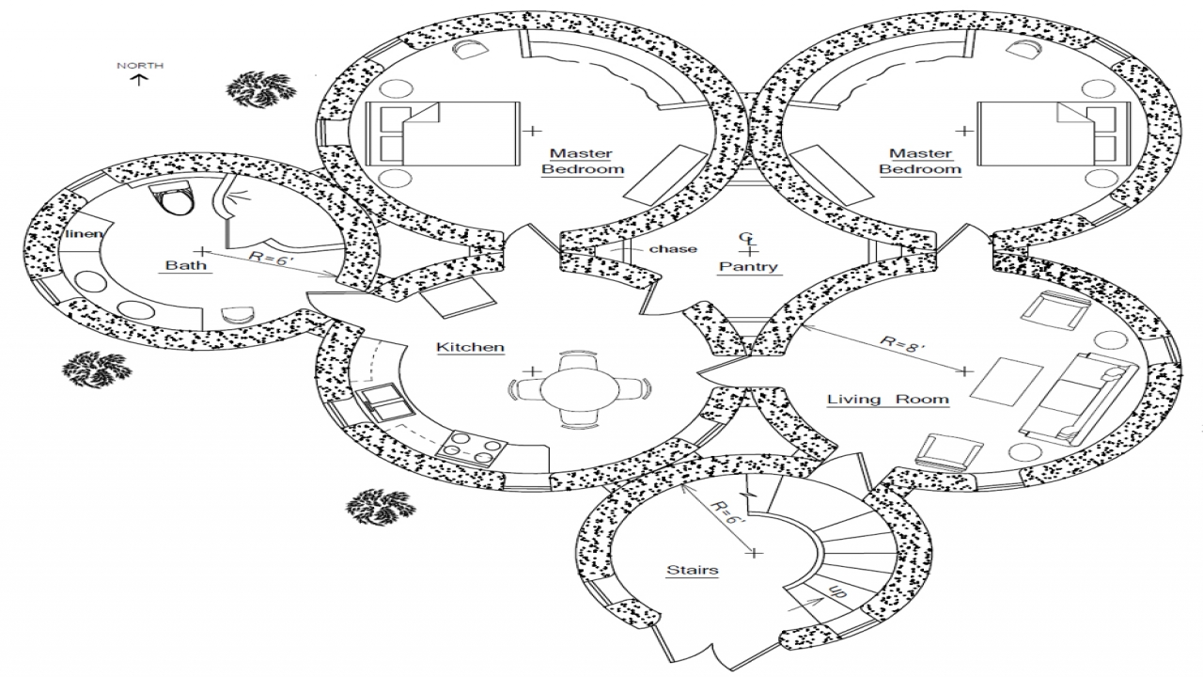
Appendix A: Hobbit Hole Template

Appendix B: Character Planner
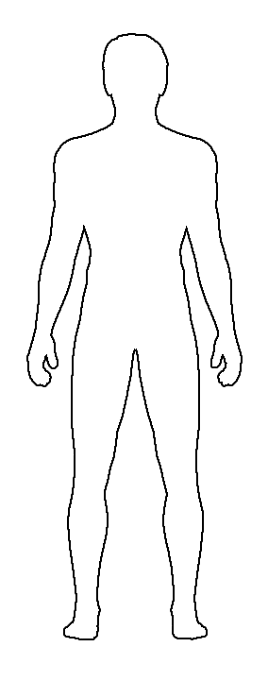
How do they look and sound?

Name: _________________
Age: ___________________
Race: __________________
Where do they live? _______________________
Weapon(s): _____________
_______________________
Clothes: ________________
_______________________
_______________________
_______________________
What skills does your character have that helps them in their life and work? ___________________________________________________________________________
___________________________________________________________________________
___________________________________________________________________________

What are their biggest hopes and fears? ____________________________________________________________________________
___________________________________________________________________________
___________________________________________________________________________
___________________________________________________________________________

What makes them a brave and courageous character? What have they done previously that inspired hope in others?_______________________________________________________
___________________________________________________________________________
___________________________________________________________________________
___________________________________________________________________________
___________________________________________________________________________

Character Description

___________________________________________________________________________

___________________________________________________________________________

___________________________________________________________________________

___________________________________________________________________________

___________________________________________________________________________

___________________________________________________________________________

___________________________________________________________________________

___________________________________________________________________________

___________________________________________________________________________

___________________________________________________________________________

___________________________________________________________________________

___________________________________________________________________________

___________________________________________________________________________

___________________________________________________________________________

Appendix C: Creative Planner
Beginning | Middle | End

Colours | Adjectives / Adverbs | Senses
Synonyms for Feelings | Similes, Metaphors, Personification

Appendix D: Rune Quest
Rune Decoder
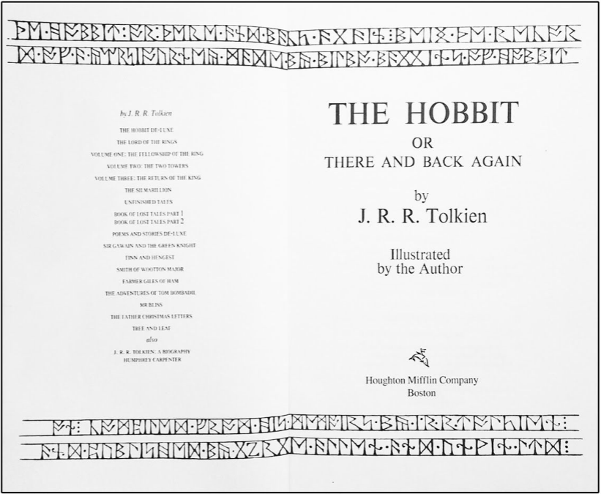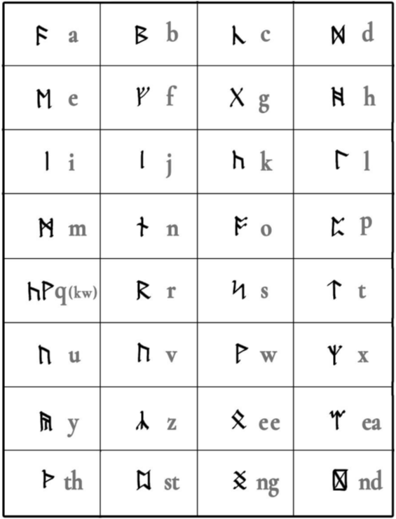
Decode the runes here:________________________________________________________________________________________________________________________________________
_______________________________________________________________________________________________________________________________________________________________

Appendix E: Background Information on Runes

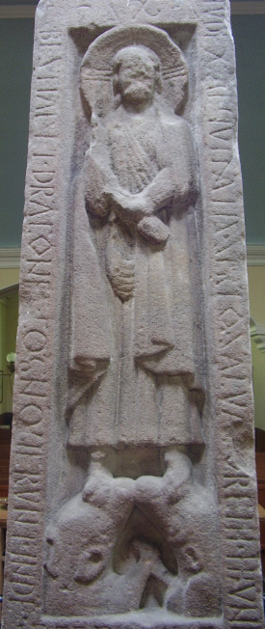
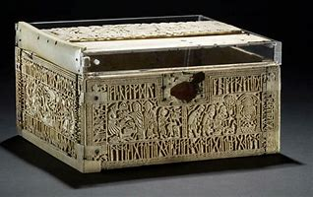
Runes were a form of writing used across Northern Europe during the early Middle Ages - the time of the Anglo-Saxons and Vikings. Tolkien adapts a few of the real signs and gives a key to translating them.
It is important to point out that runes have no connection with witchcraft or paganism. They have been misused by the unwise and those who pretend to have supernatural powers. In reality, runes were used to express Christian ideas and ideals as well as for more practical purposes. They were thought to have magical powers because language itself was once thought to have magical power. The power of runes was used to protect and heal, to show devotion and to express faith in the way later forms of writing have been used to write out prayers, and set down knowledge.
Two of the most famous examples of the use of runes are both Christian in intention. The runes on the Franks casket c. 700 AD that form a border around a carving of the Coming of the Magi as well as around a carving of the myth of Weland the Smith. Here they mark the transitional stage between the pagan Norse beliefs and the conversion to Christianity. On the right is a picture of the Frank casket.
The second example is the Ruthwell Cross which was carved in the 8th century with runes that tell part of the story of The Dream of the Rood in the Northumbrian dialect. The Dream of the Rood is a lament in the form of a poem, and it expresses the sorrow the Cross itself because it is being used for the Crucifixion of Christ. The Cross itself speaks of Christ as a hero who accepts his death for the greater good. Below is a close up picture of the runes on the Ruthwell Cross.
The runic alphabet was known as the futhorc from the first seven signs with which it began. Each rune had a name and it could 'mean' its name.
Example: æ, its name was æsc, meaning 'ash-tree'. It could refer to an ash-tree, or be used in a word that needed the 'a' sound we say in words like 'hat'. The rune þ is called 'thorn' and could be used to refer to a thorn on a plant, or as part of a word where a 'th' sound is needed.
If you look at the names of the runes you will find out a little about what was important in the society that used them. The ash-tree was important because spear shafts were made from it.
There was more than 1 futhorc and the forms of the runes varied from country to country.
These differences are reflected in the way Tolkien refers to dwarf runes and Daeron's runes.
He also used altered forms of runes, and runic spellings that pick up these differences in the runic inscriptions on The Hobbit map.

